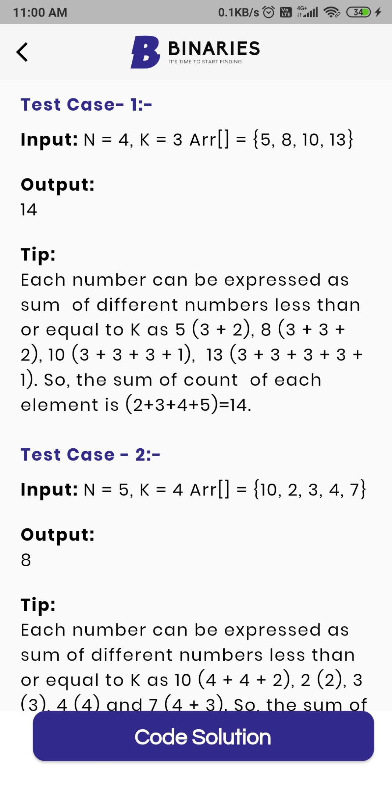

import java.util.\*;

public class Main

{

public static void main(String[] args) {

Scanner sc=new Scanner(System.in);

int n=sc.nextInt();

int a=sc.nextInt();

int[] arr=new int[n];

int c=0;

for(int i=0;i<n ;i++ ){

arr[i]=sc.nextInt();

if(arr[i]%a==0){

c+=arr[i]/a;

}

else{

c+=arr[i]/a;

c+=1;

}

}

System.out.println(c);

}

}